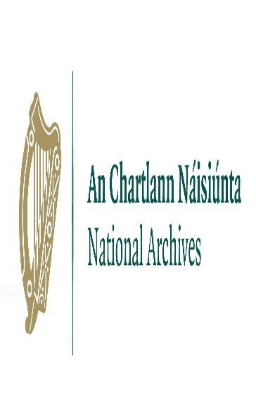

National Archives’ Filming Application Form

PRODUCTION TITLE

YOUR FULL NAME, POSITION AND COMPANY NAME

CONTACT DETAILS (PHONE NUMBER, EMAIL AND POSTAL ADDRESS)
If you are based overseas, please state the country (including the international dialing code)

PRODUCTION DETAILS
Please tell us the duration of the production, where and when it is going to be broadcast

HOW WILL THE NATIONAL ARCHIVES FEATURE IN THE PRODUCTION?
Please explain the context within which the National Archives will appear

WHEN WOULD YOU LIKE TO FILM?
Filming takes place in the National Archives between 9.30am-12.30pm and 1.30pm-4.30pm, Monday to Friday. The crew must be off site by 5pm.

Out-of-hours filming can be arranged but must be negotiated well in advance and may incur additional costs for security.

HOW LONG WOULD YOU LIKE TO FILM FOR?

PLEASE LIST THE DOCUMENTS YOU WOULD LIKE TO FILM, PROVIDING FULL REFERENCES
Please be specific as possible in your answer – for more information on providing correct file references, please visit www.nationalarchives.ie/historical-records/referencing-archives

HAVE YOU ALREADY BEEN IN CONTACT WITH STAFF AT THE NATIONAL ARCHIVES ABOUT THE PROPOSED FILMING?
If yes, please provide the staff member’s name and what has been discussed

WOULD YOU LIKE TO INTERVIEW A MEMBER OF STAFF?
If yes, please state the name of the staff member you wish to interview

I have read and agreed to the filming terms and conditions, including the charges and cancellation policy

Name: _______________________________________________________________

Date: ________________________________________________________________

