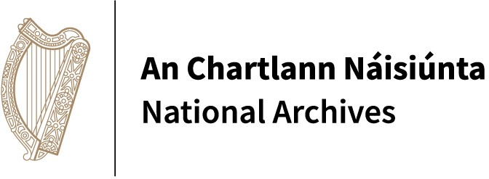

SUMMER IN THE NATIONAL ARCHIVES

26 June at 11am: ‘Testamentary and
court records in the NAI’ (Culture Club) (Gregory O’Connor, NAI)

24 July at 11am: ‘Digitisation in the NAI’ (Culture Club)
(Hazel Menton, NAI)

28 August at 11am: ‘Fenian records
in the NAI’ (Culture Club)
(Brian Donnelly, NAI)

Please join us for these free events!

